
VILNIUS GEDIMINas Technical university
Faculty of Electronics
department of Electronics systems

Machine Learning
Laboratory work 6
Authors: Kirill Postrehan, EDIfu 24/1
Lecturer: Dr. Olusola Oluwakemi Abayomi Alli

VILNIUS 2026
Introduction:
In this laboratory work, I preprocessed Spotify dataset and then tried different algorithms to find the most suitable one for the problem.
Task:
For many of these algorithms in order to find optimal number of clusters I used elbow, Silhouette, calinski harabasz and davies bouldin methods. Balancing between the data the provided I decided what number o clusters I will use on models. For the majority of them I used 3 clusters. In order to plot multidimensional data I used PCA to reduce dimensionality to 2.

The first one to test was KMeans:
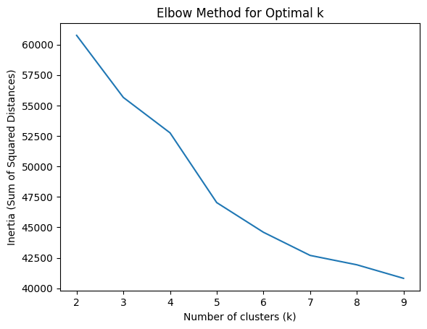
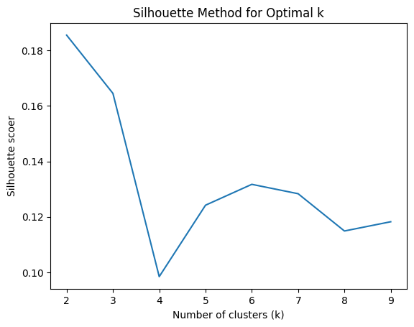
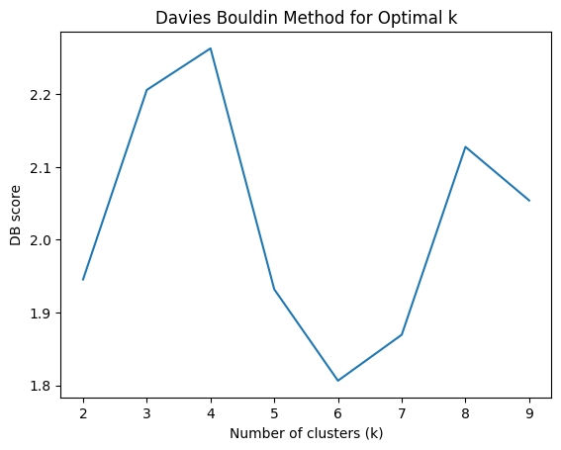
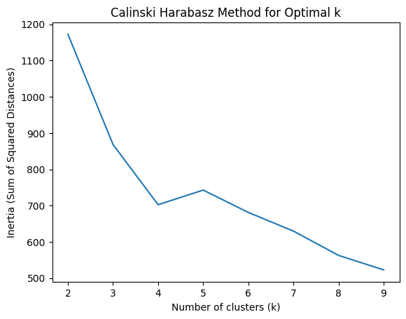
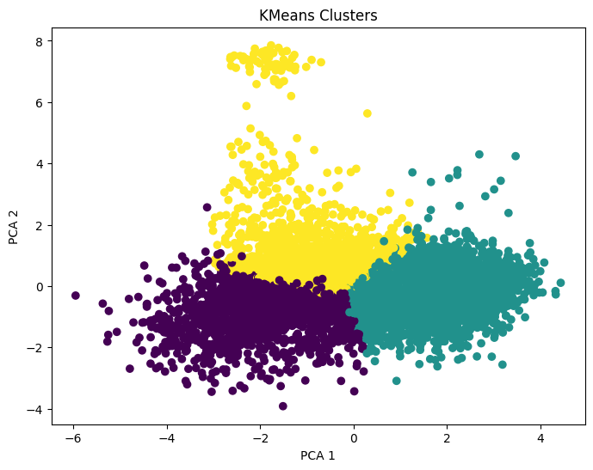
We see that there are 3 almost well separated clusters.
KMedoids:
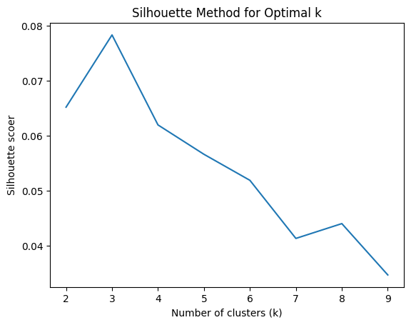
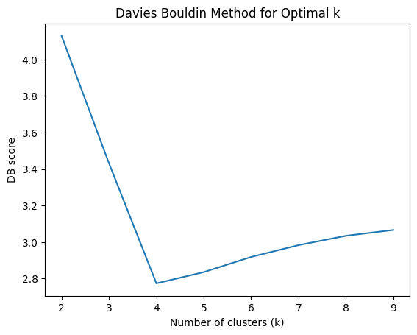
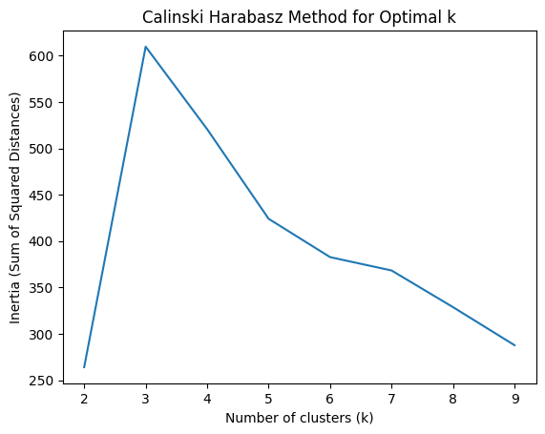
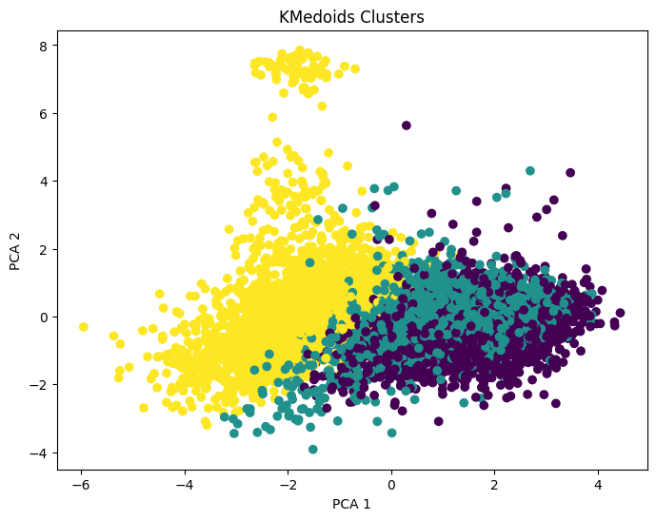
Yellow cluster is clearly separated, but other two overlap. This suggests that there may naturally be only two clusters. But nevertheless it still has weak cluster structure.
CLARA:
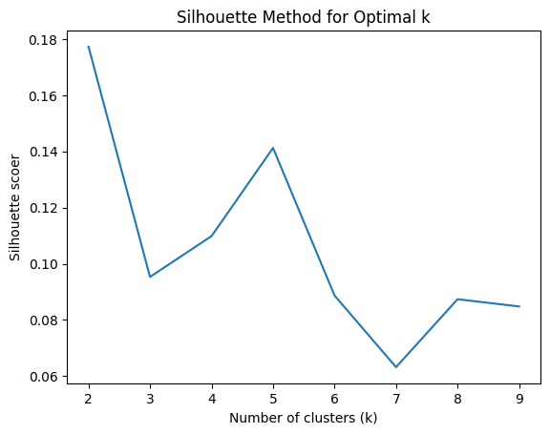
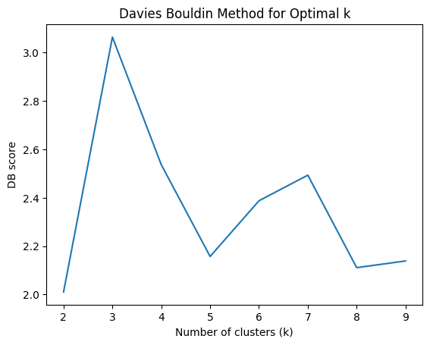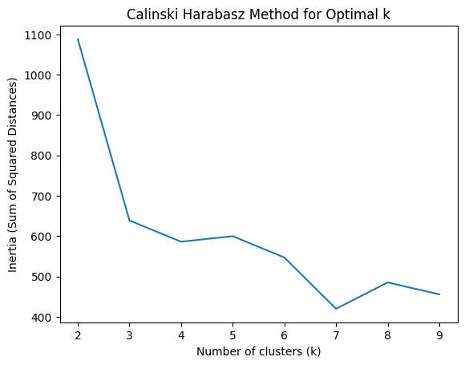

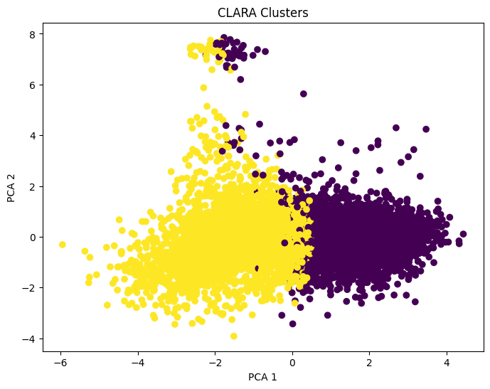
CLARA performs better because it samples the dataset and avoids being influenced by overlapping regions, resulting in a clearer separation into two dominant clusters.

Hierarchical (Agglomerative method):
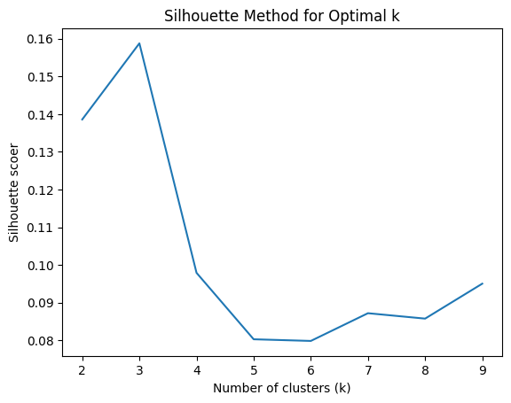
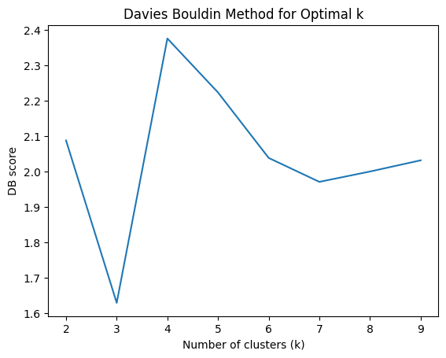
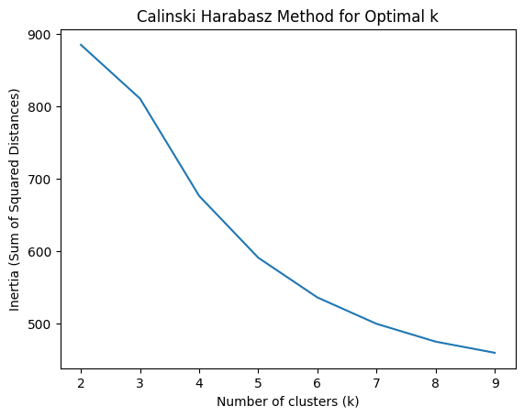

With 3 clusters:
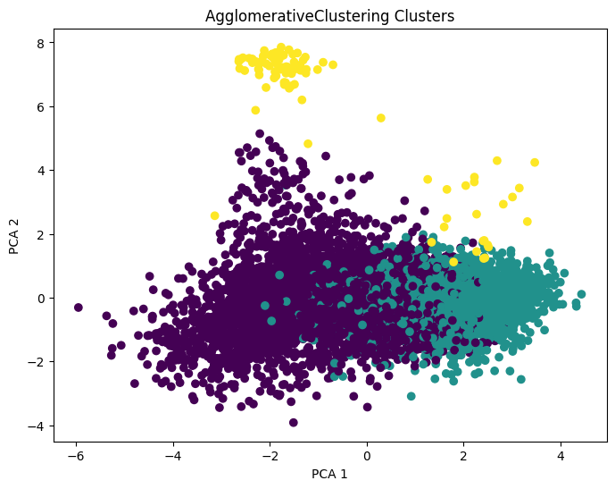
This shows not a really good result. Bottom clusters overlap and yellow is dispersed.
With 2 clusters:
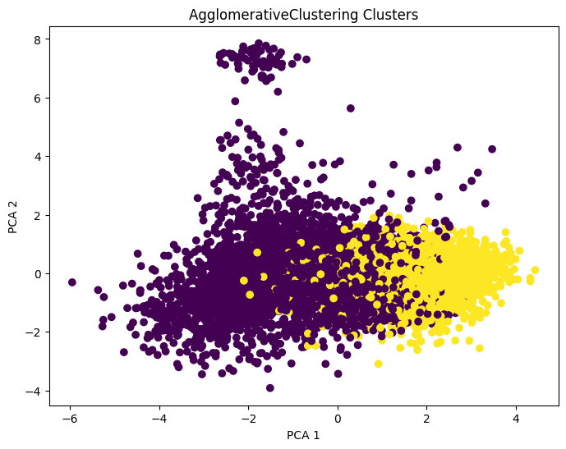
Results are actually weak. The overlap between two clusters remains to be the same.

Density-based method (DBSCAN):
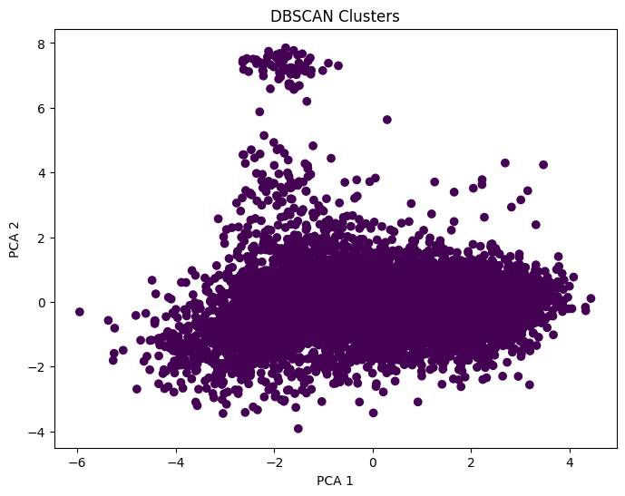
DBSCAN identifies one large cluster because the data points are densely distributed without clear low-density gaps separating them. This indicates the absence of natural cluster boundaries.

Model based (Self-Organizing Map (SOM)):
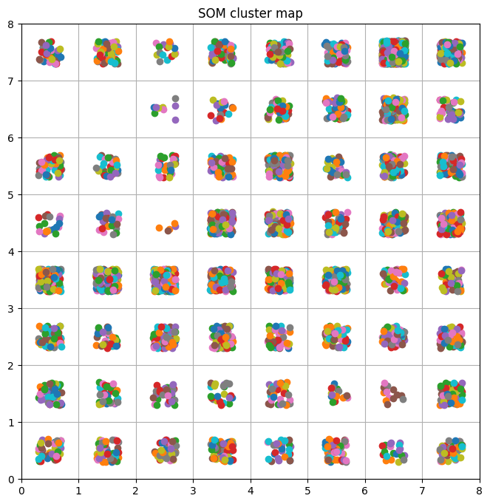
Data is spread across almost all neurons, so does not form a few tight clusters — it’s continuous smoothly distributed.

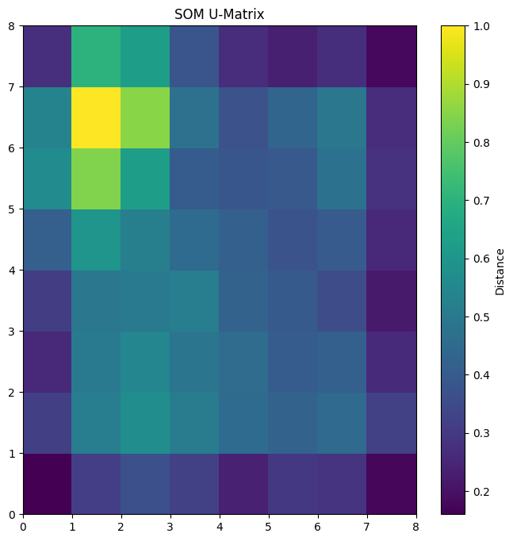
The yellow here means that it is a strong separation in data at those coordinates.
Based on very dark cells those might be clusters. So here might be 3-4 clusters
Conclusion:
The clustering results indicate that the dataset does not contain clearly separable clusters. Partition-based methods such as K-Means and PAM produce overlapping clusters due to the continuous nature of the data. Hierarchical clustering provides similar results. In contrast, DBSCAN is able to identify dense regions and noise points, while the Self-Organizing Map reveals the underlying structure of the data through a continuous mapping. Therefore, density-based and SOM approaches are more suitable for this dataset.

